Backend
Login module required for all these 3 project
Login module
emailId, password, typeofuser (3 property)
customer, admin, etc
student, factuly, admin etc
SignIn
SignUp
Functionality
Rest API for SignIn and SignUp
Admin module
Admin can add car details, add, delete, update and retrieve
Admin can view all car details.
Customer module
View all car details, search the particular if present book the car.
mongo db : is a native module to connect database.
or
moongose : schema base module to connect the mongo db database.

Frontend React JS
Create React JS project using vite framework
Redux toolkit, routing, react-router axios
SignIn component
SignUp component
Admin dashboard
Customer dashboard

Backend
Create the folder with name as backend
Input init
npm init -y
npm install express mongoose bcrypt dotenv
npm install nodemon --save-dev

frontend -folder
npm create vite@latest frontend-app
cd frontend-app
npm install
npm install axios react-redux @reduxjs/toolkit react-router-dom

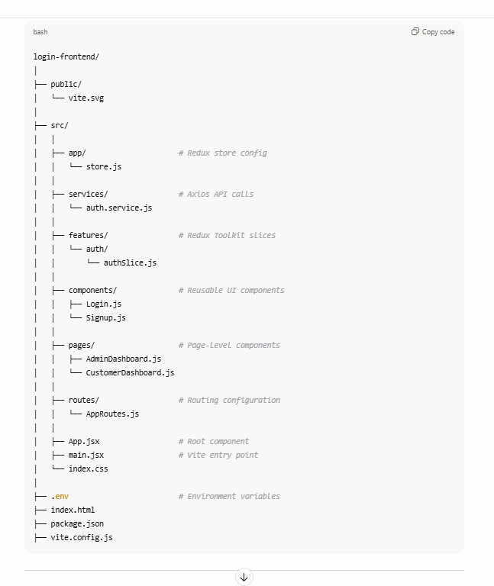

need react js frontend app for login-app module with redux toolkit with axios third party library for signin, signup with emailid, password, typeofuser and admindashboard and userdashboard with routing features

